EE463 Software Project 1 Part 3

3.1

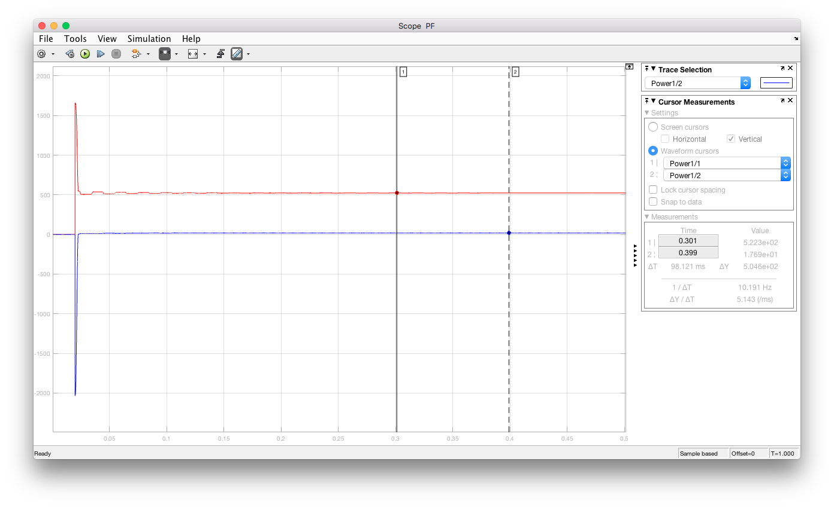

Figure 1: Graphical data obtained for input real and reactive powers for the first case.

From this graph we can conclude that the power factor is 0.999 leading which is understandable since grid inductance and load capacitance balance each other out.

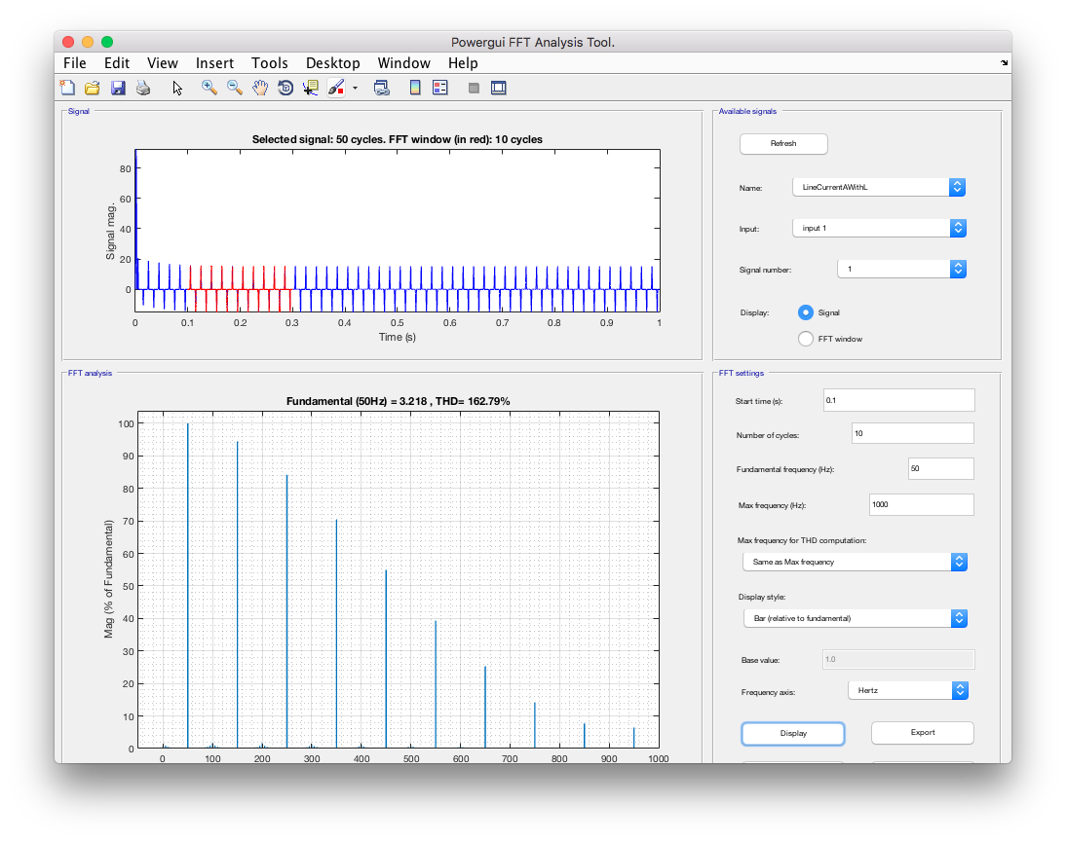

Figure 2: Graphical data obtained for THD analysis for the first case.

As it is evident from the bar graph in figure 2 the THD value of input current is 162.79%. This means the effect of the harmonics is high which is not desirable.

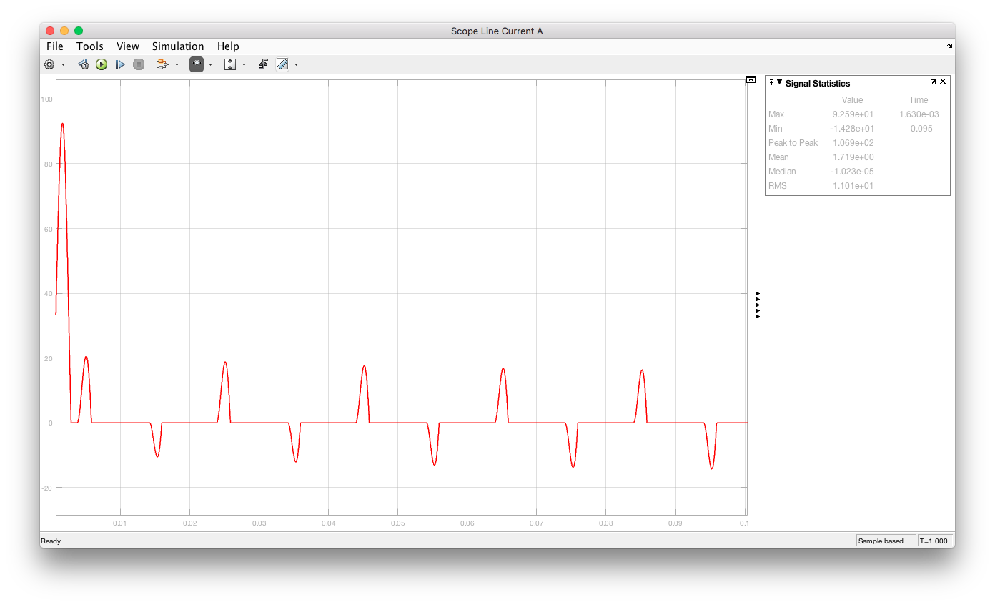

Figure 3: Graph for phase-A current for the first case.

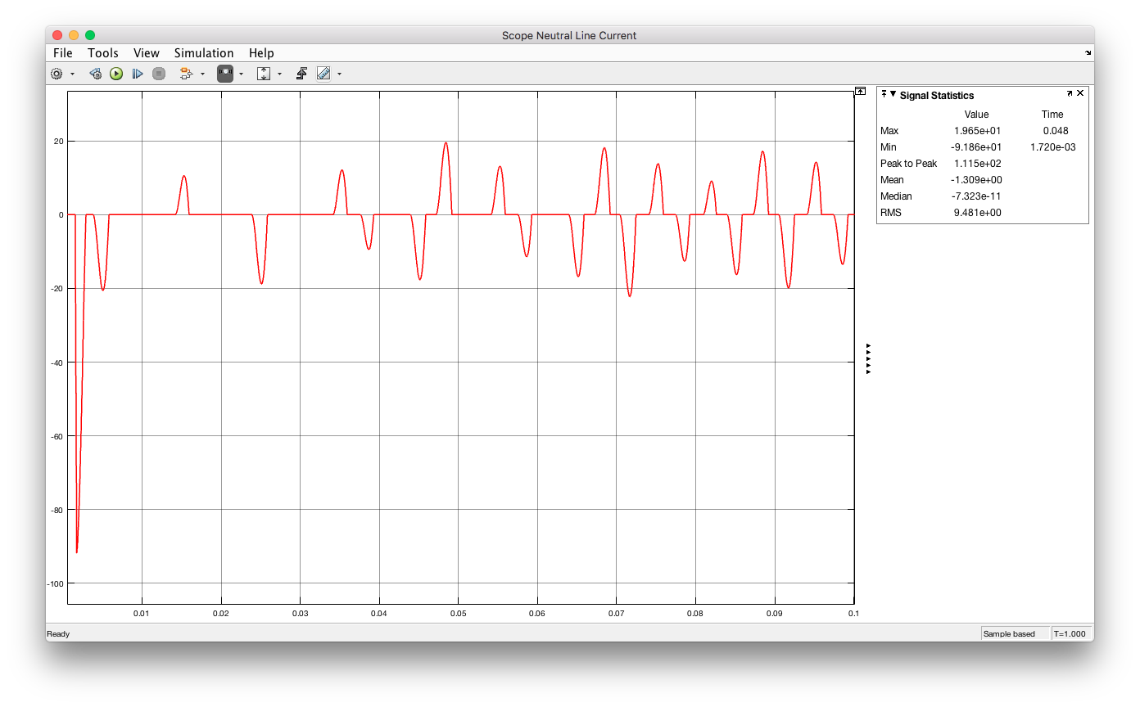

Figure 4: Graph for neutral wire current for the first case.

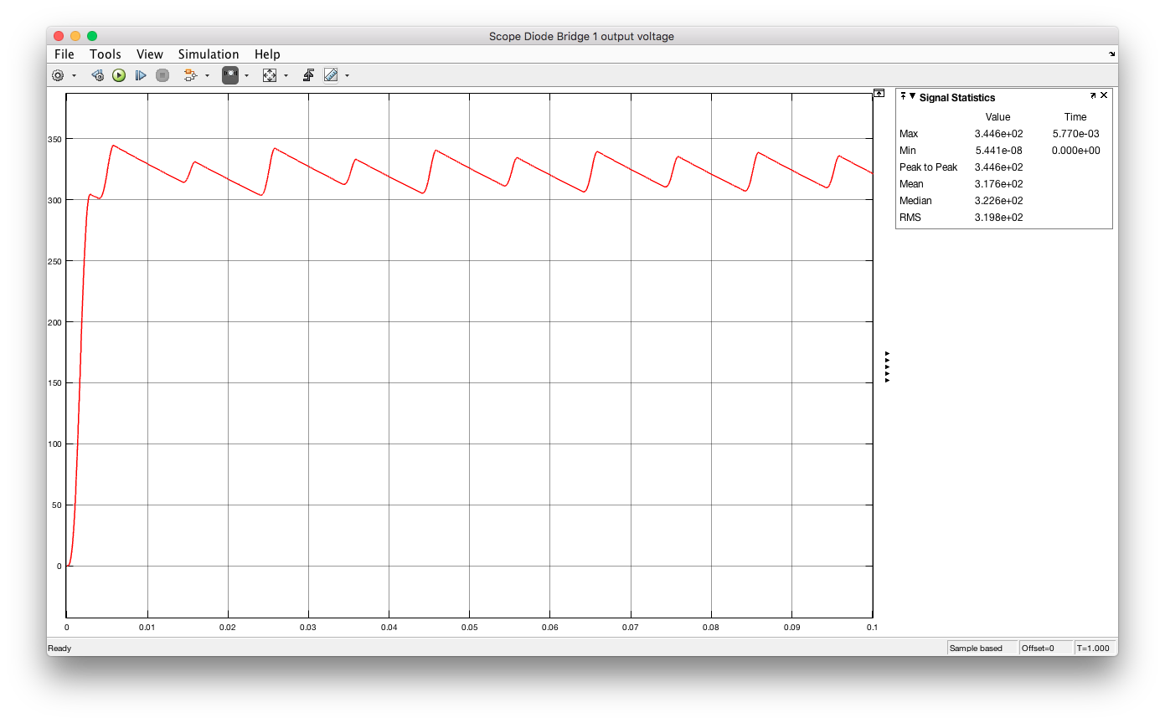

Figure 5: Graph for Diode Bridge 1 output voltage for the first case.

3.2

As can be read from the graphs RMS value for the line current A is 11 Arms and as far as the other lines are concerned they are close to this value (7.55Arms for line B and 8.95 Arms for line C).

As for the neutral line current, the RMS value is 9.48 Arms.

3.3.1

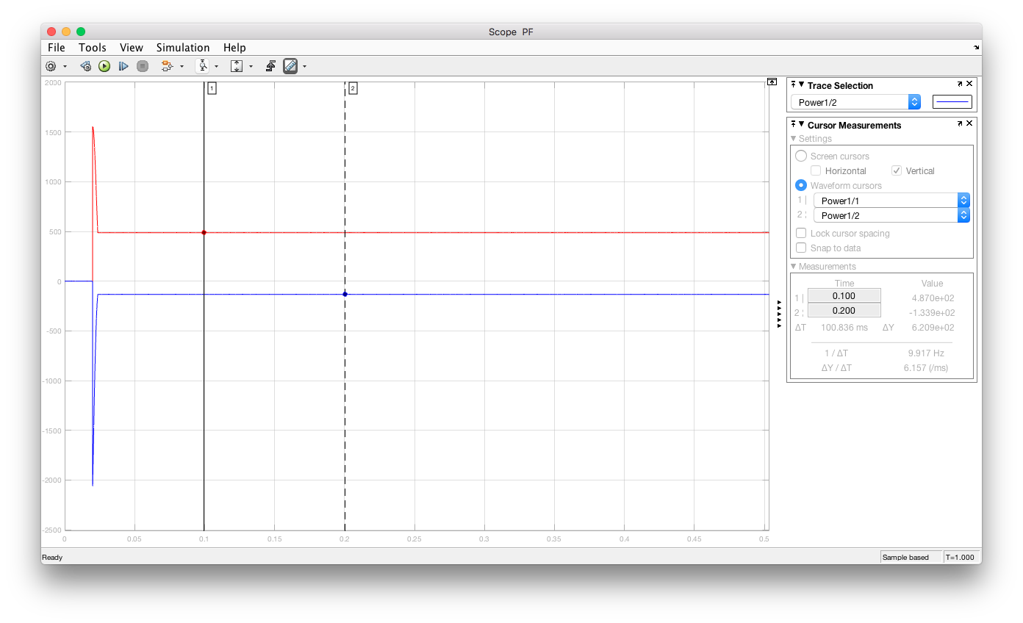

Figure 6: Graphical data obtained for input real and reactive powers for the second case

From this graph we can conclude that the power factor is 0.96 leading which is slightly different from the first case but different nonetheless. This difference is caused by the lack of the grid inductance.

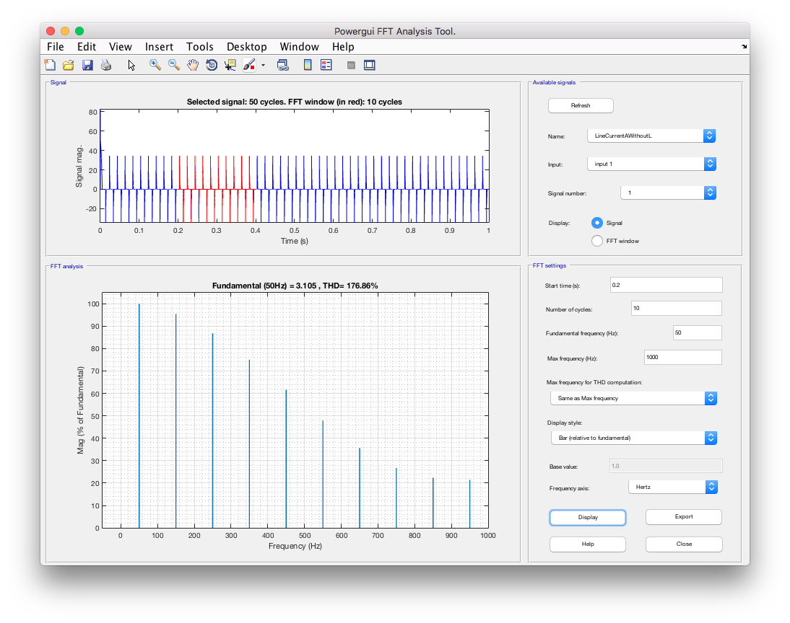

Figure 7: Graphical data obtained for THD analysis for the second case.

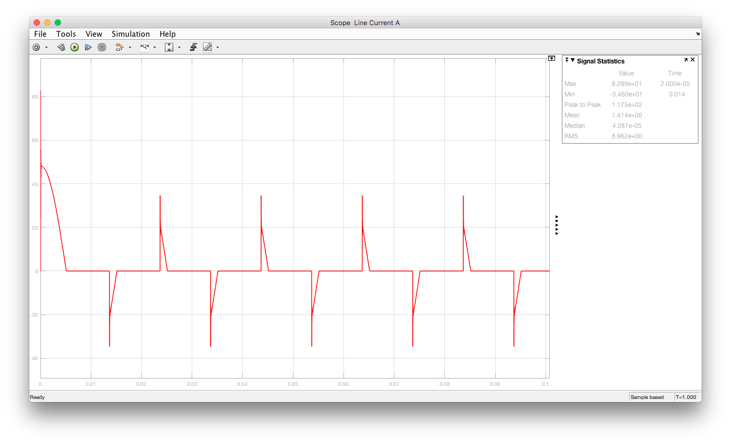

Figure 8: Graph for phase-A current for the second case.

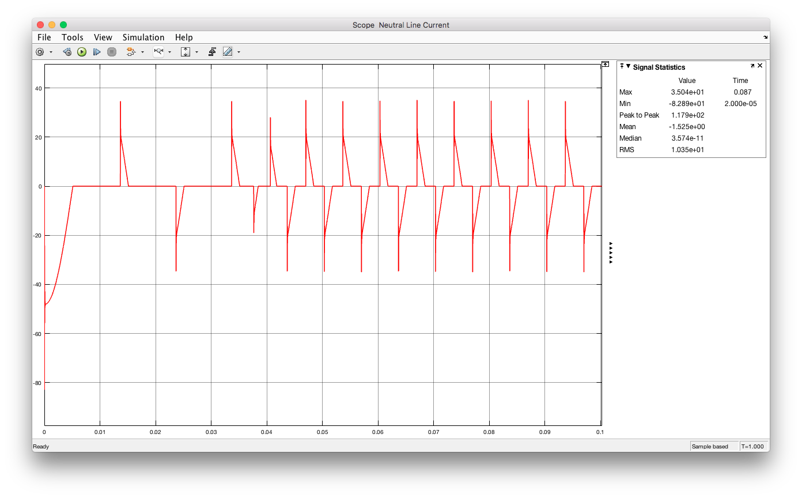

Figure 9: Graph for neutral wire current for the second case.

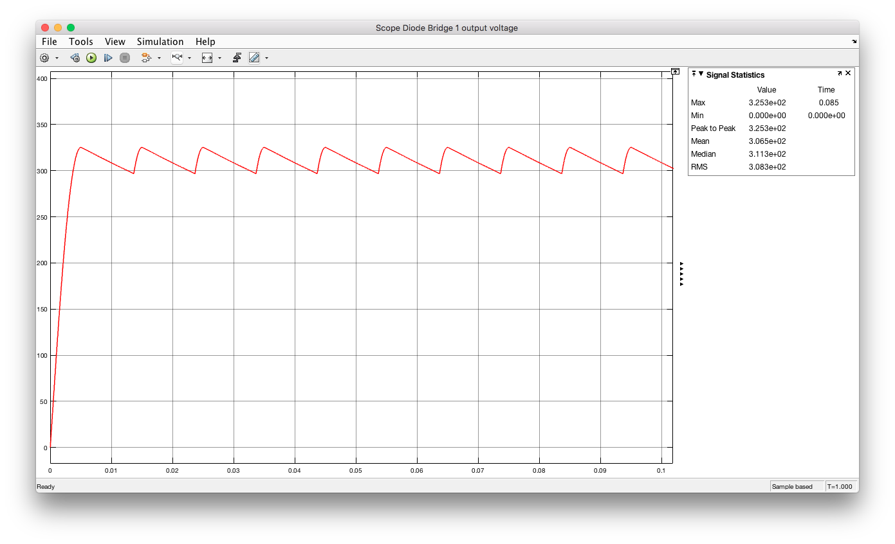

Figure 10: Graph for Diode Bridge 1 output voltage for the second case.

3.3.2

As can be read from the graphs RMS value for the line current A is 8.96 Arms and as far as the other lines are concerned they are close to this value (7.64Arms for line B and 7.64 Arms for line C).

As for the neutral line current, the RMS value is 8.48 Arms.